Lamp Lighting & Oath Taking Ceremony At Government College Of Nursing Kanpur
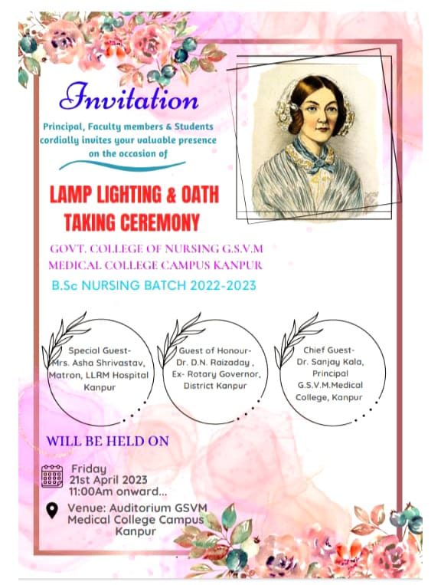
The Government College of Nursing, Kanpur conducted the ‘Lamp Lighting & Oath Taking Ceremony” on 21st April 2023 in Auditorium of GSVM Medical College Campus Kanpur under the able leadership of Lt. Col Dr. Karesh Prasad, Principal, college of Nursing GSVM Medical College Campus.
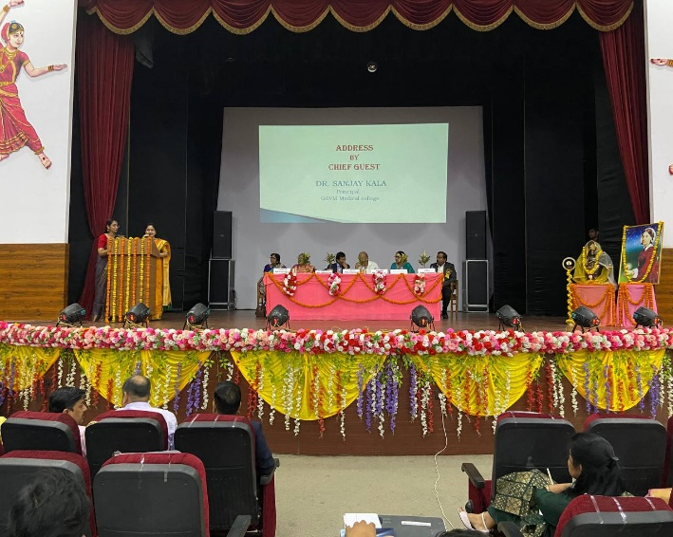
The Lamp Lighting ceremony is an auspicious occasion in every nurse’s life, held irreverence to Florence Nightingale the lady with Lamp light as a symbol of knowledge, removes ignorance & is a lasting wealth by which a lot could be achieved. The Lamp lighting ceremony formally recognizes the student’s entry into the nursing profession.
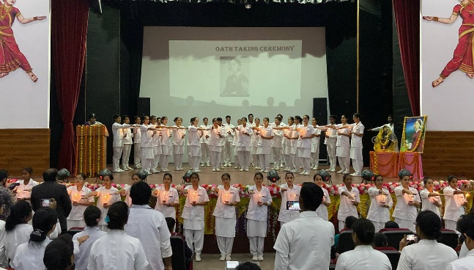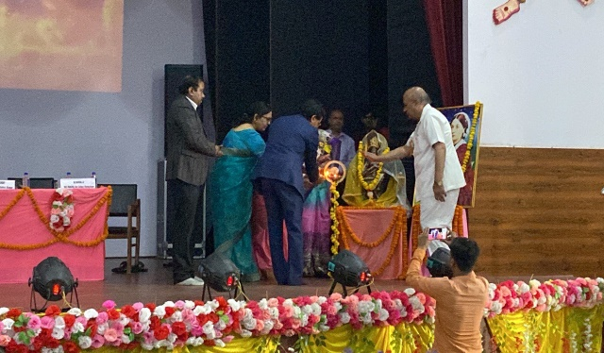

The program started by welcoming the guest who includes Dr. Sanjay kala Principal GSVM Medical College, Kanpur as a Chief Guest, Dr D.N. Raizaday, Ex- Rotary Governor District Kanpur as Guest of honor, Mrs. Asha Srivastava Nursing Superintendent, as Special guest, Lt. Col. Dr Karesh Prasad Principal Govt. College of Nursing Kanpur.
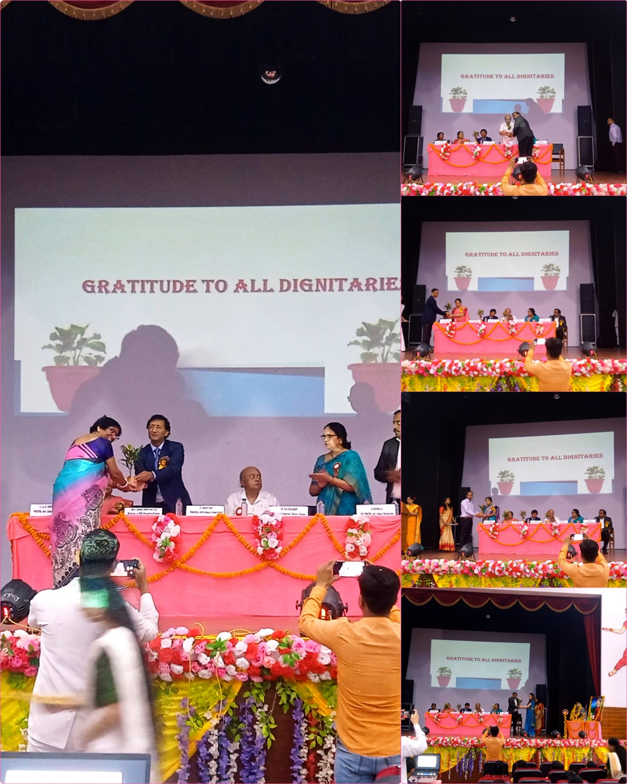

After a Warm Welcome by the faculty members of the institute, the Guests were escorted to light the traditional lamp Principal GSVM Dr Sanjay Kala, Ex- Rotatory Governor, Dr D.N. Raizaday Nursing Superintendent Mrs. Asha Srivastava, Lt. Col Dr Karesh Prasad, Principal Government college of Nursing Kanpur and Prof. Naveena J H Vice Principal College of Nursing, Kanpur lightened the lamp.
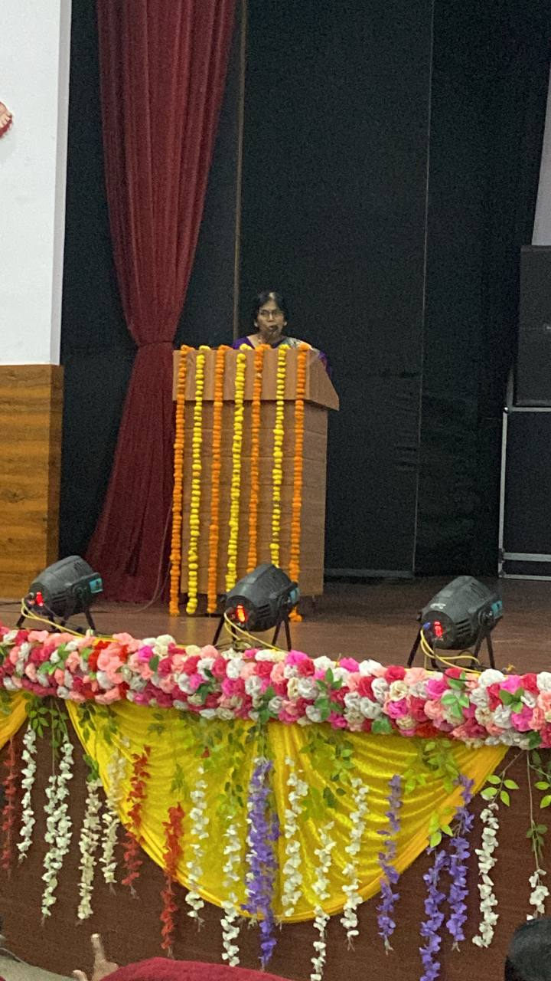
Principal of Government college of Nursing Kanpur welcomed the guest. She presented the annual report where she have an account of achievements made by the institute. She explained how the momentous task of molding the minds of this young generation with a mission, to nurture each student nurse to make a compassionate & discerning individual can be achieved.
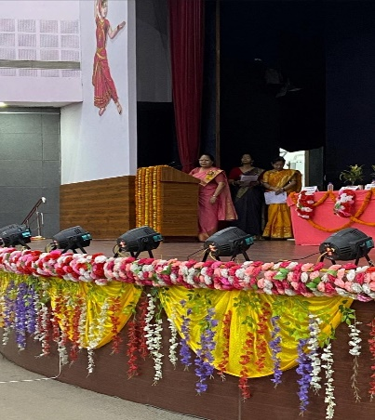
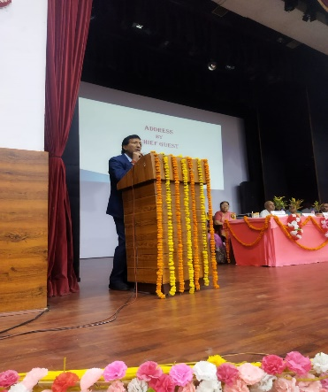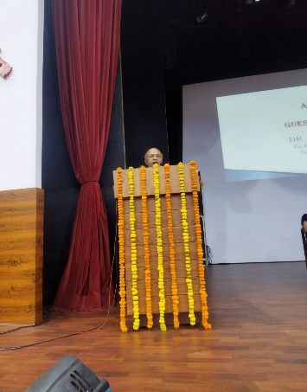
Chief Guest Address the Quality care of patient, shares personal experiences related to hospital and motivate the students regarding their profession.
Guest of Honor Address the Quality care of patient, motivate the students regarding their profession.
Special Guest LLRM Hospital Kanpur, in their addresses spoke on nursing leadership, with special emphasis on patient safety & Infection control.

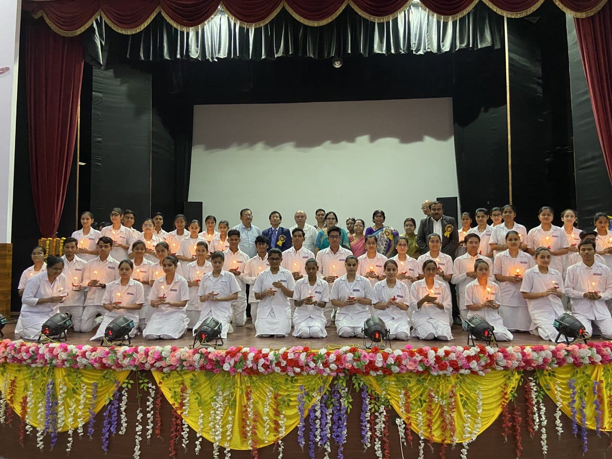
The Lamp Lighting ceremony began with the students marching forward to take their positions & be ready to accept the light. This is considered as the first step towards their professional life. The lamp of wisdom was ignited by Principal Govt. College of Nursing Kanpur who passed on the light to the faculty members who further lightened the candles of the students.
Lt. Col Dr Karesh Prasad led the students take the Nightingale pledge. The students promised to fulfill their duties & practice their profession sincerely by repeating the pledge with outstretched hands as a symbol of making a promise.
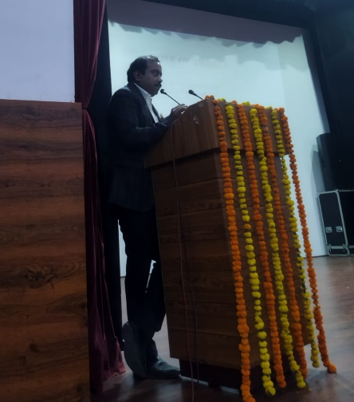
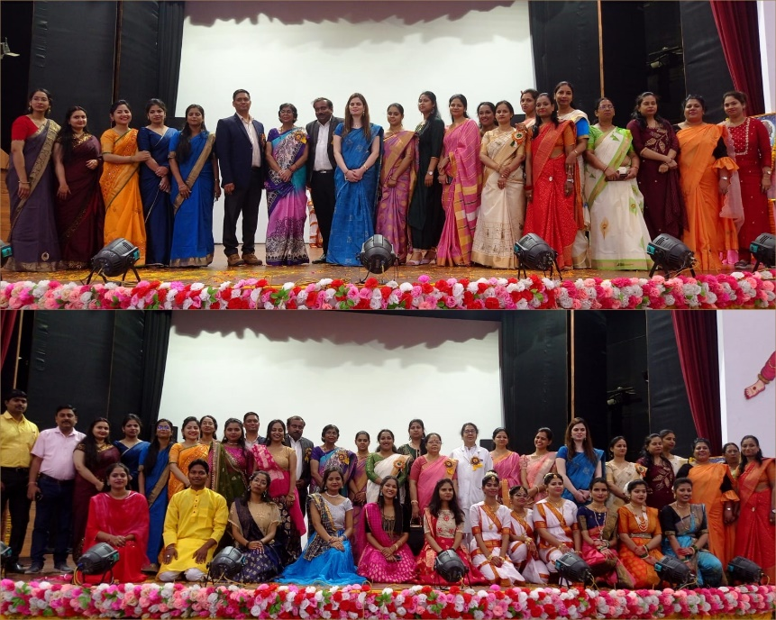
The students presented a brief cultural programme consisting of regional dances. The event Concluded with a Vote of Thanks. By Vice Principal Mr. Naveena J.H

